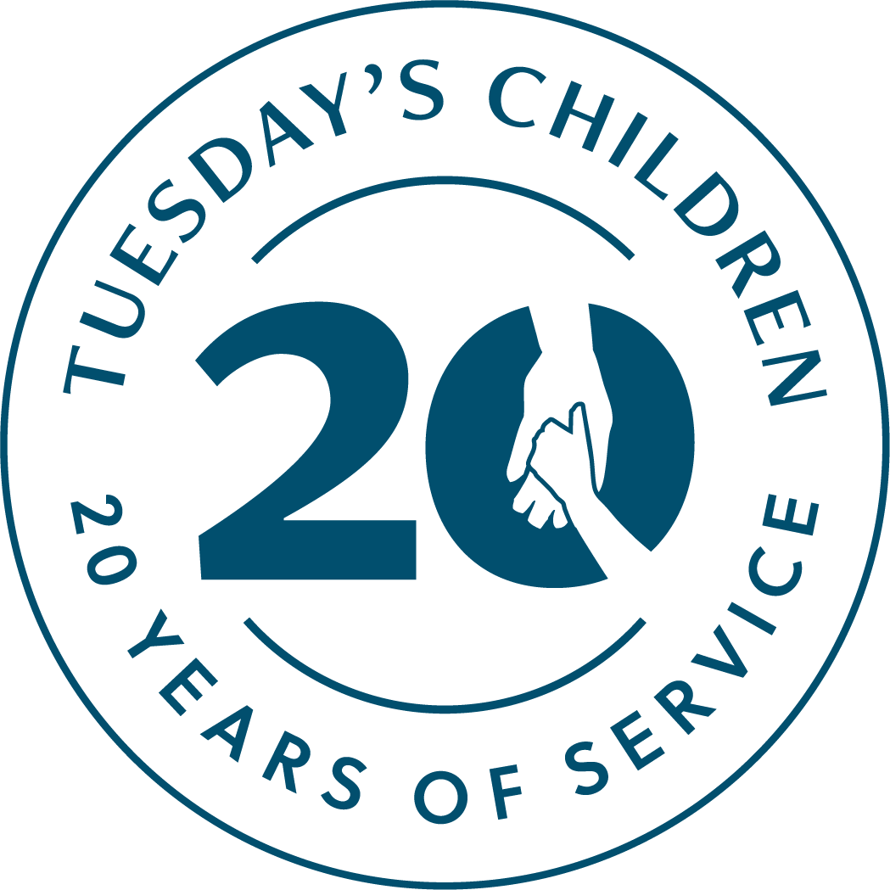

Rise Up and Remember: 9/11 5K
Tuesday’s Children Social Media Tool Kit

Social Media
Please be sure to post on social media before, during and after the race. We encourage you to use the event hashtag and tag Tuesday's Children (see below) on all platforms so we can share your wonderful success to our network of families and supporters.

Additionally, you are welcome to use the suggested copy and graphics from our social media tool kit. Please scroll down to page two to view.

CLICK HERE to view and download graphics accompanying each post.

#September5KTC
Facebook: @tuesdayschildren
Twitter: @tuesdayschldrn
Instagram: @tuesdayschldrn
LinkedIn: @tuesday’s children

For all questions regarding social media, please contact Emily@tuesdayschildren.org.

For those participating in the Rise Up and Remember: 9/11 5K – Post #1

Facebook
I’m excited to participate in @tuesdayschildren‘s Rise Up and Remember: 9/11 5K this September as they honor their 20 Years of Service.

Donate now and help me provide a lifetime of healing for families who have been forever changed by terrorism, military conflict or mass violence. #September5KTC

**insert your personal classy fundraising link**

Twitter
I’m excited to participate in @tuesdayschldrn‘s Rise Up and Remember: 9/11 5K this September as they honor their 20 Years of Service.

Donate now! #September5KTC

**insert your personal classy fundraising link**

Instagram
I’m excited to participate in @tuesdayschldrn‘s Rise Up and Remember: 9/11 5K this September as they honor their 20 Years of Service.
.
Donate now at the link in my bio and help me provide a lifetime of healing for families who have been forever changed by terrorism, military conflict or mass violence. #September5KTC
.
Insert your personal classy fundraising link in your bio.
(For assistance on how to add a link into your bio, please contact Emily@tuesdayschildren.org.)

LinkedIn
I’m excited to participate in @tuesday’s children‘s Rise Up and Remember: 9/11 5K this September as they honor their 20 Years of Service.
.
Donate now and help me provide a lifetime of healing for families who have been forever changed by terrorism, military conflict or mass violence. #September5KTC
.
**insert your personal classy fundraising link**

For those participating in the Rise Up and Remember: 9/11 5K – Post #2

Facebook
@tuesdayschildren is bringing back their Rise Up and Remember 5K this September and I can’t wait to participate! Register now and join me in support of their work for families who have been forever changed by terrorism, military conflict or mass violence. #September5KTC

https://give.tuesdayschildren.org/9115k2021

Twitter
.@tuesdayschldrn is bringing back their Rise Up and Remember 5K this September and I can’t wait to participate! Register now and join me in support of their work. #September5KTC

https://give.tuesdayschildren.org/9115k2021

Instagram
@tuesdayschldrn is bringing back their Rise Up and Remember 5K this September and I can’t wait to participate! Register now (link in their bio) and join me in support of their work for families who have been forever changed by terrorism, military conflict or mass violence. #September5KTC

LinkedIn
@tuesday’s children is bringing back their Rise Up and Remember 5K this September and I can’t wait to participate! Register now and join me in support of their work for families who have been forever changed by terrorism, military conflict or mass violence. #September5KTC

https://give.tuesdayschildren.org/9115k2021

For those not running but still looking to promote the Rise Up and Remember: 9/11 5K – Post #3

Facebook
@tuesdayschildren is hosting another Rise Up and Remember 5K this September in honor of their 20 Years of Service.

Participants from all over the nation will gather virtually to walk and run in support of their work for families impacted by terrorism, military conflict or mass violence. #September5KTC

Register now at https://give.tuesdayschildren.org/9115k2021.

Twitter
.@tuesdayschldrn is hosting another Rise Up and Remember 5K this September in honor of their 20 Years of Service.

Participants from all over the nation will gather virtually in support of their work. #September5KTC

Register now at https://give.tuesdayschildren.org/9115k2021.

Instagram
@tuesdayschldrn is hosting another Rise Up and Remember 5K this September in honor of their 20 Years of Service.
.
Participants from all over the nation will gather virtually to walk and run in support of their work for families impacted by terrorism, military conflict or mass violence. #September5KTC
.
Register now at the link in their bio.

LinkedIn
@tuesday’s children is hosting another Rise Up and Remember 5K this September in honor of their 20 Years of Service.

Participants from all over the nation will gather virtually to walk and run in support of their work for families impacted by terrorism, military conflict or mass violence. #September5KTC

Register now at https://give.tuesdayschildren.org/9115k2021.

